120″ Telescope Coude′ Focus

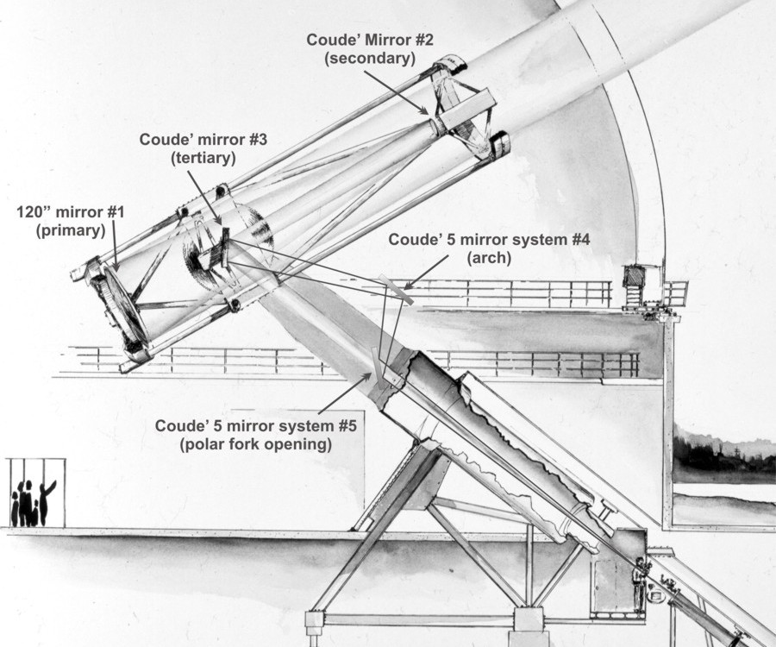

Optic # | Optic Notes | Procedures
#1 | Bare aluminum  Subjected to oil drips and occasional moisture  Up facing mirror – Protective cover | Inspect monthly  Co₂ monthly  Wash annually
#2 | Bare aluminum  Bad glass – coating degrades within 6 months  Down facing mirror – Protective cover | Inspect monthly  Carefully wash as needed
#3 | SiO overcoated aluminum  Subjected to oil drips and occasional moisture  Up facing tertiary mirror – Protective cover | Inspect monthly  Co₂ every other month  Wash as needed
#4 | SiO overcoated aluminum  Down facing arch mirror – Protective cover | Inspect every 6 month  Wash as needed
#5 | SiO overcoated aluminum  Subjected to much dust and dirt  Up facing mirror in fork polar opening – Protective cover | Inspect every 6 month  Co₂ every other month  Wash as needed

